
Project Initialization and Planning Phase
Date | 15 March 2024 26 July 2026
Team ID | xxxxxx EduGenie - Google Gemini Powered Learning Assistant
Project Name | xxxxxx EduGenie - Google Gemini Powered Learning Assistant
Maximum Marks | 3 Marks
Define Problem Statements (Customer Problem Statement Template):
Create a problem statement to understand your customer's point of view. The Customer Problem Statement template helps you focus on what matters to create experiences people will love. A well-articulated customer problem statement allows you and your team to find the ideal solution for your customers' challenges. Throughout the process, you’ll also be able to empathize with your customers, which helps you better understand how they perceive your product or service.
Example:
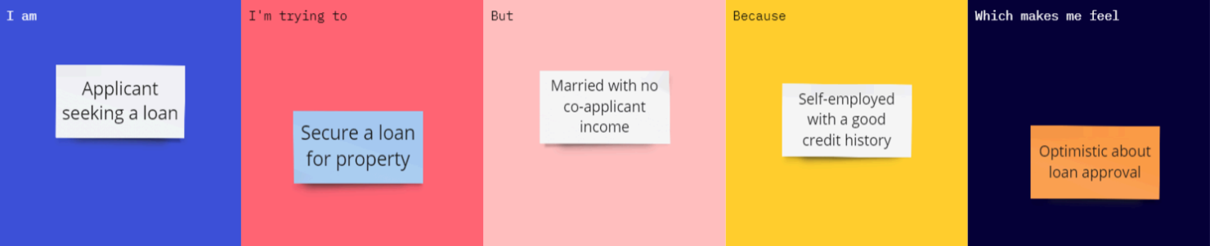
Problem  Statement (PS) |  | I am  (Customer) | I’m trying to |  | But |  |  | Because |  | Which makes me feel
PS-1  School / college School / college student studying PS-1  student studying independently  independently | u in q | nderstand a new or difficult concept in dependently quickly A male applicant  seeking a loan. | f | gets generic, unstructured Secure a loan engines  engines  for the  property |  | gets generic, unstructured Married with engines  no co-applicant  income. | m to to | m ost tools aren't tailored  to their learning level to their learning level Self-employe  d with a good  credit history. | ove  . | overwhelmed and demotivated  Optimistic about  loan approval.
PS-2
Student preparing for Student preparing for  exams  exams | test their own understanding of a topic |  |  | has no quick way to  understanding of a topic generate practice  questions from notes or a questions from notes or a topic  topic |  | manually writing quiz  questions is slow and questions is slow and  questions from notes or a tedious topic | manually writing quiz questions is slow and questions is slow and tedious  tedious
PS-3  Self-learner exploring Self-learner exploring a new subject  a new subject | Self-learner exploring a new subject what order what order |  |  | figure out what to study structure a learning path structure a learning path |  | doesn't know how to  roadmaps for niche topics roadmaps for niche topics are hard to find  are hard to find | curated, leveled  roadmaps for niche topics roadmaps for niche topics are hard to find  are hard to find |  | directionless and slow to make progress

